Github Explore

Roy Van

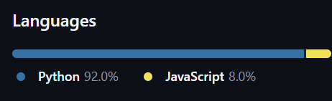The project I am interested in is “browser-use”, it is a powerful and innovated tool to connect your browser and artificial agent. In short, this project can enable the interaction between your browser and your artificial agent, let an AI assistant that can read your screen to accomplish your task. The primary programming language used is Python, and it can be easily installed into your computer using a few commands with Python version>=3.11. The key features of it include helping you write a letter to someone in Google Docs, adding ideal items(under a certain price, or only looking for grocery items) into the cart, and seeking suitable jobs based on your resume. This project is actively updating, the latest update published is in four hours, and receiving 29.6k stars, 3k forks, and 76 contributors to date. The project is very appealing to people including me, looking to automate routine tasks and improve productivity. Workers, students, teachers and even anyone can benefit from it for its vast possibilities of creation. The control panel that monitors the progress of the AI in real time also stood out to me, I like to see my computer doing some chores for me automatically, even though it may not be as efficient as me personally. The combination of practical uses and exploring artificial intelligence realms attracts many contributors from the developer community to help them out, and makes this project very exciting to follow and contribute to. It has potential to revolutionize daily tasks deserve programming people to watch closely.

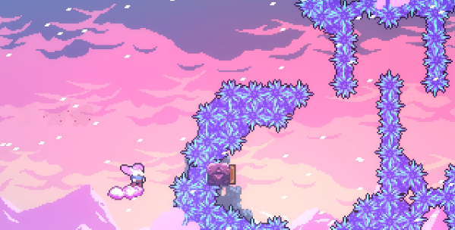文本

AI 生成的内容可能不正确。Another project that allows people to create pixel arts and animation interests me. Its named “Aseprite” and is mainly constructed by C++ and Lua, with C++ supporting the main functionalities and Lua being used for automation. The main features of Aseprite are creating pixel-based arts including environments, characters, and animations for artists and game developers. Aseprite includes a set of professional tools for drawing pixel arts, such as layers, filters and color palettes. The work created can also be exported as sprite sheets or GIFs, making it a convenient and versatile tool for game developers. Speaking of game developers, a famous 2D platformer game, Celeste, is an indie game developed by Matt Makes Games. Their chief artist Petro Medeiros has been using Aseprite in his pixel art creation process for the game, and his demonstration has been uploaded as studying materials for pixel artists. I am personally fascinated by both pixel style of art pieces and video games, besides challenging gameplay, Celeste’s beautiful arts are also impressive to me. This project lets me connect with the art design process of indie game developers who work on pixel art-based games like *Celeste*, *Stardew Valley*, and more, giving a behind-the-scenes look at the creative journey behind their visually captivating worlds. Aseprite receives 30.8k 图形用户界面, 应用程序

AI 生成的内容可能不正确。stars, 6.7k forks on Github, and is actively updating on a weekly basis. This project in under “Pixel Art” topic, it appears as the top starred project, and it fits this category as it is a powerful tool specifically designed for creating and animating pixel art aesthetic.

The navigation of Github is clear and neat, making it easy to find important information. The main navigation bar includes links to key sections: products, solutions, resources, open source, and an always visible search bar. The hierarchy of information is also very logical, allowing users to take a quick glance at the codes, issues and pull requests. The menu structure offers dropdowns for every main section, to ensure that popular links are well-categorized. All the topics come with the author’s name, tags, number of stars, last update time, and a short project description. This is a very helpful format when users are looking for projects that interest them. In respect of visual design, Github employs a modest color combination, which gray, black and blue dominates, rendering a professional, uninterrupted environment for programmers. The typography is modern, fonts and sizes of texts and codes are reasonable; as well as great uses of white space in project descriptions, avoiding visual cluster. The visual hierarchy is also consistent; topics, tags and icons all work well in guiding users’ attention. Across different pages, they intentionally remain consistent on user interface to ensure users can easily adapt to other sections of the website without confusion. More importantly, on the detailed page of projects, the design is also straightforward. README file, issues, pull requests, contributors, sponsors and more key elements are neatly present on prominent positions. The avatars of contributors are displayed as badges, and the status of projects both appeals to more potential contributors. Technical information such as coding language usage appears as a chart, aligning with percentages, allowing specific coding language learners to find some valuable examples. Finally, topic pages provide another method for users to filter those unfamiliar projects and find their interests compared to regular project pages, encouraging users to support or engage with their beloved areas of programming.

References & Citations

@software{browser_use2024,

author = {Müller, Magnus and Žunič, Gregor},

title = {Browser Use: Enable AI to control your browser},

year = {2024},

publisher = {GitHub},

url = {https://github.com/browser-use/browser-use}

}

<https://github.com/topics/pixel-art> Pixel arts Topic on Github

<https://github.com/aseprite/aseprite> Aseprite project

<https://github.com/browser-use/browser-use> Browser-use project

<https://www.bilibili.com/video/BV1y84y1d7Yt/> Celeste chief artist introducing Aseprite in his process of creating pixel arts for Celeste.